**MY SQL- QUESTIONS**

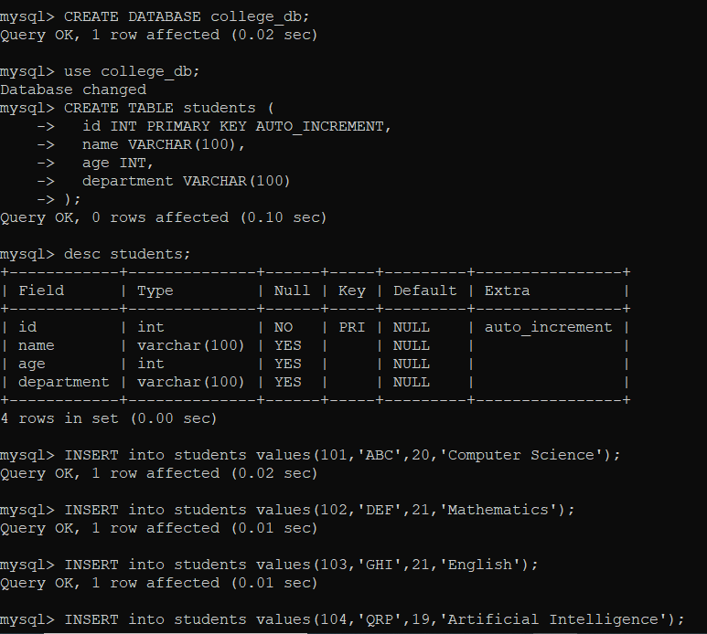

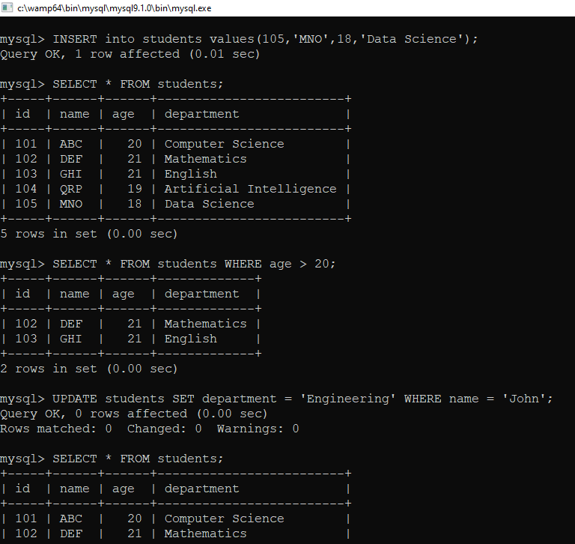

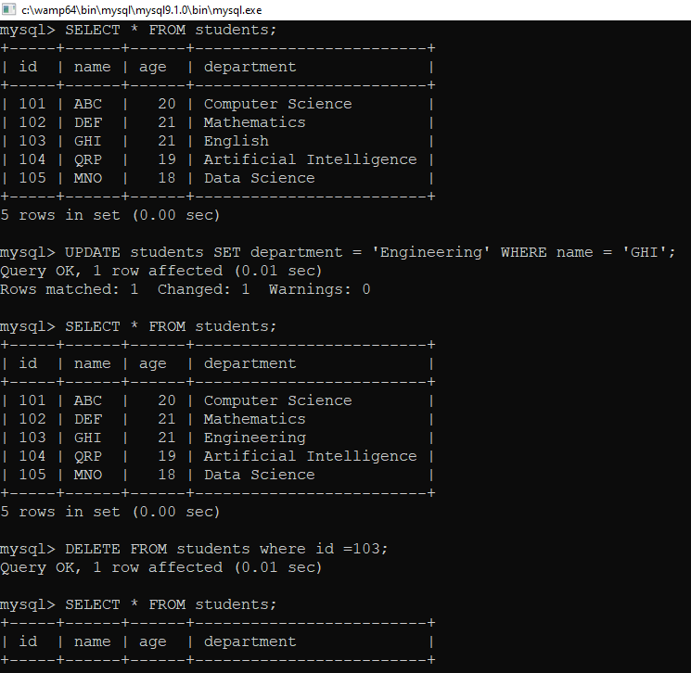

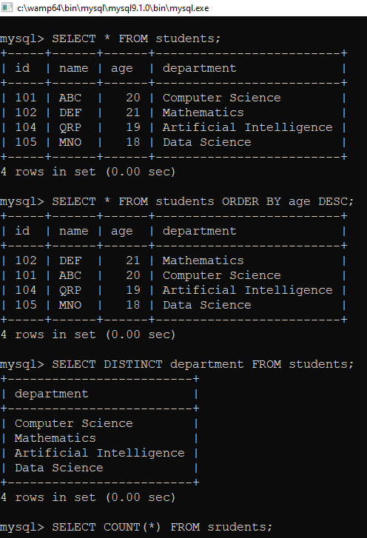

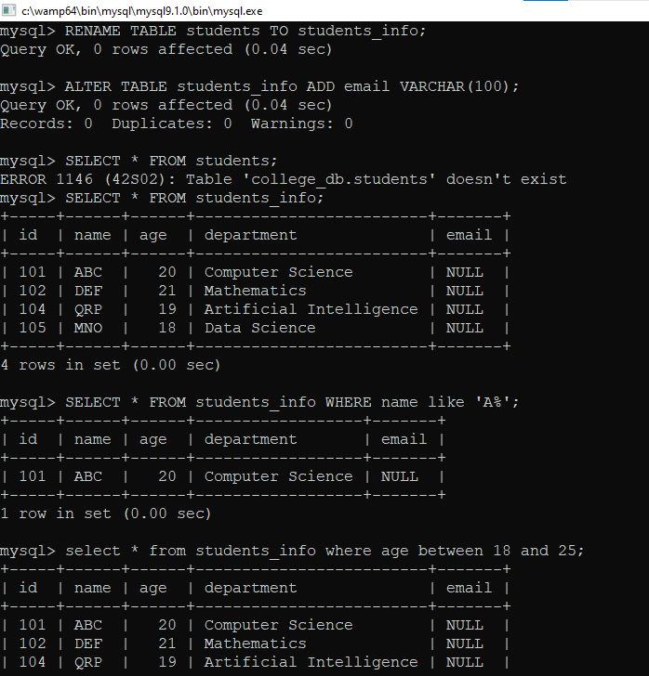

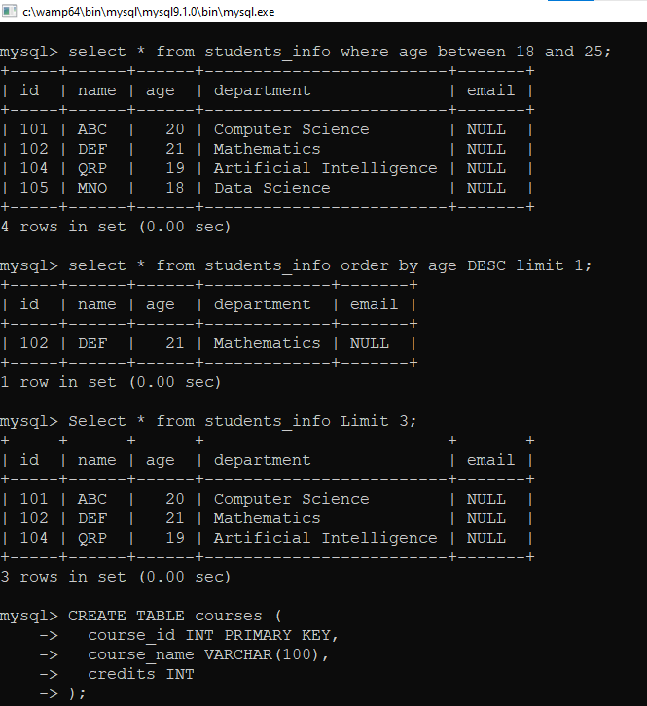

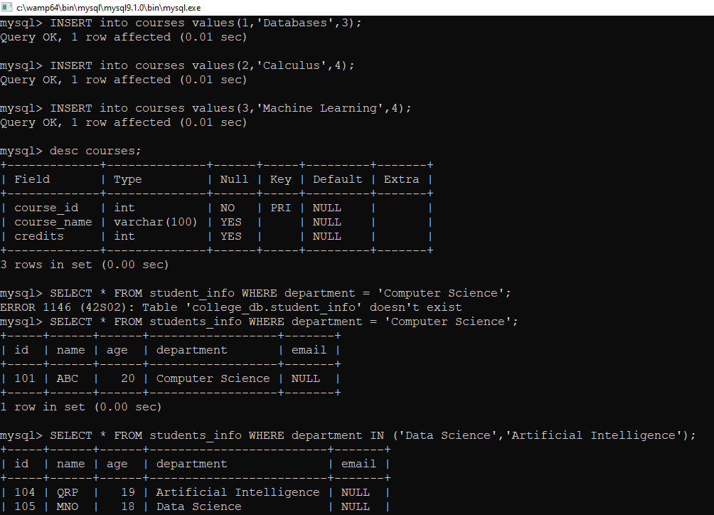

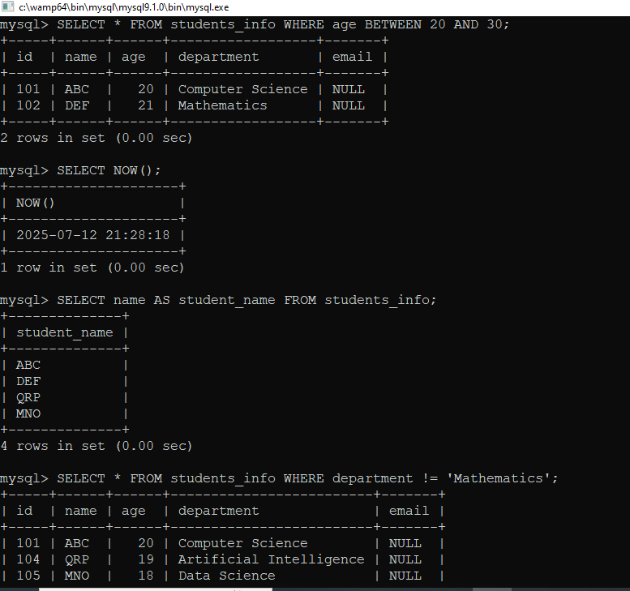

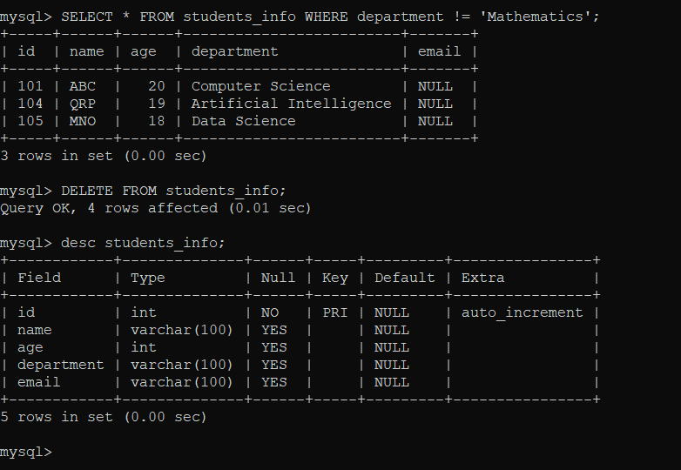

COLLEGE_DB

/*!40101 SET NAMES utf8mb4 */;

-- Database: `college_db`

-- --------------------------------------------------------

-- Table structure for table `courses`

DROP TABLE IF EXISTS `courses`;

CREATE TABLE IF NOT EXISTS `courses` (

`course_id` int NOT NULL,

`course_name` varchar(100) DEFAULT NULL,

`credits` int DEFAULT NULL,

PRIMARY KEY (`course_id`)

) ENGINE=InnoDB DEFAULT CHARSET=utf8mb4 COLLATE=utf8mb4_0900_ai_ci;

-- Dumping data for table `courses`

INSERT INTO `courses` (`course_id`, `course_name`, `credits`) VALUES

(1, 'Databases', 3),

(2, 'Calculus', 4),

(3, 'Machine Learning', 4)

-- --------------------------------------------------------

-- Table structure for table `students_info`

DROP TABLE IF EXISTS `students_info`;

CREATE TABLE IF NOT EXISTS `students_info` (

`id` int NOT NULL AUTO_INCREMENT,

`name` varchar(100) DEFAULT NULL,

`age` int DEFAULT NULL,

`department` varchar(100) DEFAULT NULL,

`email` varchar(100) DEFAULT NULL,

PRIMARY KEY (`id`)

) ENGINE=InnoDB AUTO_INCREMENT=106 DEFAULT CHARSET=utf8mb4 COLLATE=utf8mb4_0900_ai_ci;

COMMIT;

/*!40101 SET CHARACTER_SET_CLIENT=@OLD_CHARACTER_SET_CLIENT */;

/*!40101 SET CHARACTER_SET_RESULTS=@OLD_CHARACTER_SET_RESULTS */;

/*!40101 SET COLLATION_CONNECTION=@OLD_COLLATION_CONNECTION */;